## CS/SE 3340 Homework 5: Compression Program

## Worth 200 points

Objective: Gain more experience with MIPS programming, and in using macros.

Overview: In this program you will implement a very simple compression algorithm, RLE, as described in Wikipedia:

**Run-length encoding** (**RLE**) is a very simple form of lossless data compression in which *runs* of data (that is, sequences in which the same data value occurs in many consecutive data elements) are stored as a single data value and count, rather than as the original run. This is most useful on data that contains many such runs.

For example, ‘AABBBC’ would be encoded as: ‘A2B3C1’

### Instructions

Macro File: Create macros to print an int, print a char, print a string, get a string from the user, open file, close file, read file, and allocate heap memory. You can use more macros than these if you like.

Main Program File:

1. Allocate 1024 bytes of dynamic memory and save the pointer to the area.
2. The main program is a loop in which you ask the user for a filename. If they enter nothing for the filename, exit the program. Otherwise:
   1. Open the file for reading. If the file does not exist, print an error message and terminate the program.
   2. Read the file into an input buffer space of 1024 bytes.
   3. Close the file.
   4. Output the original data to the console.
   5. Call the compression function. Save the size of the compressed data in memory.
   6. Call a function to print the compressed data.
   7. Call the uncompress function. Print the uncompressed data.
   8. Print the number of bytes in the original and compressed data.
3. The compression function implements the RLE algorithm above and stores the compressed data in the heap. Before the function call, set $a0 to the address of the input buffer, set $a1 to the address of the compression buffer, set $a2 to the size of the original file. The function should “return” the size of the compressed data in $v0.
4. The print function will repeat characters as indicated in the compressed file. For example, if the compressed file is ‘A2B3C1’ it will print ‘AABBBC’.
5. The uncompression function does the reverse of the compression function, saving the result to an uncompressed buffer in static memory.

What to turn in:

* Upload your .asm files to eLearning, zipped together.

Grading Rubric:

|  |  |
| --- | --- |
| **Points** | **Element** |
| 50 | Macros as described above |
| 40 | Function to compress input file |
| 40 | Function to uncompress data |
| 30 | Function to output compressed data |
| 30 | Main program with loop |
| 10 | Comments, good use of whitespace |
| 200 | Total |

Below is sample output for file error:

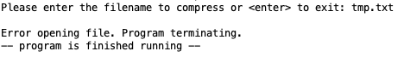

Below is sample output for file hello.txt, showing what happens when the user hits enter at the filename prompt:

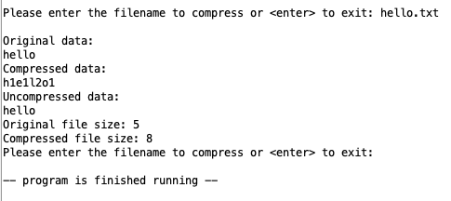

Below is sample output for file hello_art.txt. Notice that you should test hello.txt after hello_art.txt to make sure it works:

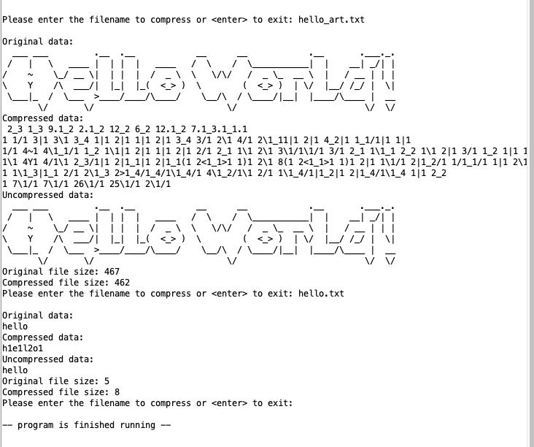

Test Files:

hello.txt

hello_art.txt

The hello world art was obtained at: <http://patorjk.com/software/taag/#p=display&f=Graffiti&t=Hello%20World>!